Analysis of Geometric Structure influence   
on   
Excited State Dynamics

Matsika Group  
Khai Nguyen  
khainguyen@temple.edu

1. **C-C Bond Lengths**

|  |  |
| --- | --- |
| *Figure 1a.* | *Figure 1b.* |

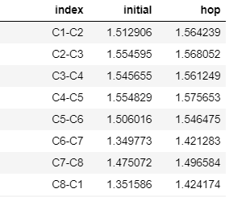

1. **C-C-C angles**

|  |  |
| --- | --- |
| *Figure 2a.* | *Figure 2b.* |

The sum of the measure of the interior angles of cyclooctadiene is (n - 2) * 180 = 1080 degrees with n = 8 being number of sides, which results in the initial value of the C-C-C being between 110 – 135 degrees.

One thing to notice is compared to the remaining C-C-C angles, the angles at C6-C7-C8 and C7-C8-C1 changes more dramatically at hop, with those angles at-hop ranging from 50 – 150 degrees.

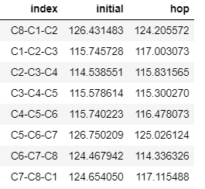

1. **Dihedral Angles**

